[Title Page]

ARTICLES WITH SHORT TITLES DESCRIBING THE RESULTS MORE OFTENLY CITED

[Title: uppercase, Times New Roman (font size 12), centered, double spacing paragraph]

[Double spacing]

JAYARAJ, V.K.¹, RAHMAH, S.² AND CHONG, J.L.^{3*}

[Uppercase, font Times New Roman, size 12 point, centered, double spacing paragraph, the surname/last name should appear first and spelt in full, comma separated and followed by initials.]

[Single spacing]

¹Complete address, ²Complete address, ³Complete address

[Lowercase, font Times New Roman, size 12 point, centered, double spacing paragraph]

[Single spacing]

*Corresponding author email:

[Lowercase, font Times New Roman, size 12 point, centered, single spacing paragraph]

[Double spacing]

Abstract: A concise, factual and structure abstract is required with maximum length of 300 words. The abstract should state briefly the purpose of the research, the principal results and major conclusions. Often, an abstract is presented separately from the article, thus it must be able to stand alone. References should be avoided. Abbreviations when first appear should be mentioned in full. [Abstract text in English, justified, double spacing, font Times New Roman, font size 12 point]

[Double spacing]

Keywords:[Left alignment, Times New Roman, font size 12]
[Immediately after the abstract, provide a maximum of 5 keywords in lower case letters, avoiding general and plural terms and multiple concepts (avoid, for example, “and”, “of” and words that are already in the title). Each keyword is separated by a comma. Only abbreviations firmly established in the field may be eligible. These keywords will be used for indexing purposes.]

[Double spacing]
Abbreviations: [Any uncommon abbreviations and ensure consistency throughout the article].

Author’s contribution

Each author contribution must be stated clearly reflecting each contribution to the body of the work and manuscript.

[Body text page: Manuscripts shall be typed in a word processing format (DO NOT SUBMIT PDF DOCUMENTS), single column, with a wide margin, double spacing, font Times New Roman, font size 12 point, page and line numbers, justified]

Introduction [Heading, left aligned, Times New Roman (font size 12), bold]

This template gives formatting guidelines for authors preparing papers for publication in the Journal of Sustainability Science and Management. The authors must follow the instructions given in the document for the papers to be published. You can use this document as both an instruction set and as a template into which you can type your own text. [First paragraph begin from the left, no spacing between paragraphs]

Citation of one reference in the text from a publication by one or two authors, name of both authors should be written (Hall, 2011; Hall & Fitzgerald, 2016).

Citation of one reference is in the text from a publication written by three or more authors, the name of the first author should be used and followed by “et al.” (Hall et al., 2008).

Citation of more than two references by the same author or authors, list the citations in chronological sequence with the earliest first, (Azmi, 2015; 2017; Mohd et al., 2017; 2018).

Citation of references for more than two publications by the same author or authors within the same year, list the citations with ‘alphabet’ after the year, (Azmi, 2015a; 2015b; Mohd et al., 2018a; 2018b; 2018c).

In case citation of references with two publications and above by different authors, list the citations in chronological sequence (Azmi, 2015; Afzan 2016; Wahi et al., 2017).
Symbols and abbreviations e.g. United Nation (UN) should be specified and spelled out for the first time. SI-units should be used wherever possible. A space must be provided after value before the unit [10 mg/L, consistent throughout the text]
[Double spacing]

Materials and Methods [Heading, left aligned, Times New Roman, font size 12, bold, capital for first letter]
Subheading One [All subheadings are left aligned, bold, italic, Times New Roman, font size 12 point, capitalised first letter for each word, no spacing between subheading and first sentence of the paragraph].
This is end of the paragraph for the subheading.

[Double spacing]

Results and Discussion

The results must clearly communicates key findings with no or minimal interpretive comment. It shall provide sufficient detail to justify any conclusions you draw later. Results can be grouped into few categories. Report most significant or general results first, then work toward more specific data. Include only those data that are relevant to the discussion that follows; raw data can be placed in an appendix. All figures and tables must be cited in the body text as Figure 1 or Table 1 (figures 1 to 3 or tables 1 to 3 if multiple figures or tables mentioned in the text). Place your figure or table immediately at the end of respective paragraph.

[Double spacing]
Table 1: Number tables (Arabic) consecutively in accordance with their appearance in the text.
[Be sparing in the use of tables and ensure that the data presented in tables do not duplicate results described elsewhere in the article. Tables should be cross referred in the text. Vertical lines should not be included in tables. Justify, font Times New Roman, size 12 point, single spacing]

[Single spacing]
 | Title 2 | Title 3 | Title 4 | Title 5 | Title 6

Text A

Text B

Text C

[Place footnotes to tables below the table body and indicate them with superscript lowercase letters.]

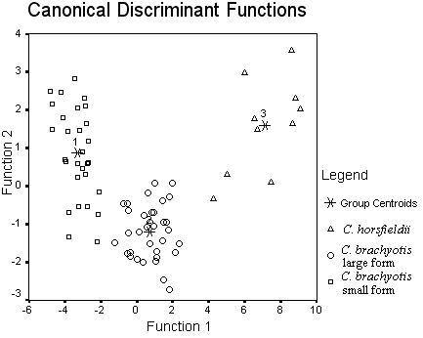

[Single spacing]
Figure 1: Number figure (Arabic) consecutively in accordance with their appearance in the text and to have a caption which should always be positioned under the figures.

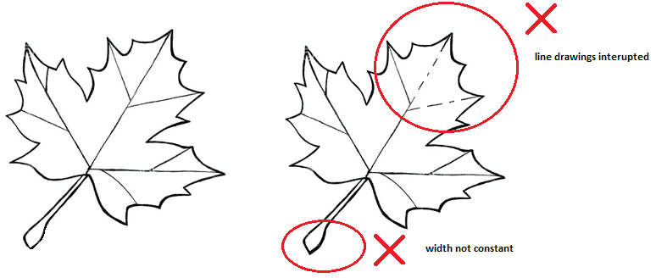
Figure 2: Guides for line drawing in figures.
[It is essential that all illustrations are clear and legible. Vector graphics should be used for diagrams and schemas whenever possible. Please check that the lines in line drawings are not interrupted and have a constant width. Grids and details within the figures must be clearly legible and may not be written one on top of the other. Line drawings are to have a resolution of at least 800 dpi (preferably 1200 dpi). The lettering in figures should not use font sizes smaller than 6 pt (~ 2 mm character height). Figures should be cross referred in the text. Caption should be justified, font Time New roman, size 12 point]
[Double spacing]

Formulas should be placed in a separate line and centered, spaced once, ended with a punctuation mark, tabbed three times and numbered. Expressions must be numbered consecutively and the numbers must be in bracket.

x + y = z (1)

Discussion must be a thorough analysis and interpretation of results in light of questions that prompted your study. Be sure to clarify whether results confirm or refute initial hypothesis. Discusses implications of work and its significance; suggests further research. Accounts for difficulties and challenges in the research, and problems in the research design. Note limitations of your approach. Clarifies how your work fits into the ongoing discussions of your field.
[Double spacing]
Subheading One
Use past tense for what was done in this study and what others found in their studies. Use present tense for universally accepted truths, findings believed to be repeatable and things really going on right now. Use future tense for what is planned for the next step, what impacts the results will have and how the results will be used.
[Double spacing]
Subheading Two
Further subheadings can be added to add sections to the discussion.

Conclusion

The conclusion connects the findings to a larger context, such as the wider conversation about an issue and the journal theme. It suggests the implications of your findings or the importance of the topic. Asking questions or suggesting ideas for further research and revisiting your main idea or research question with new insight.

[Double spacing]

Acknowledgements [double spacing, font Times New Roman, size 12 point]
Collate acknowledgements, including information on grants received. E.g. Author(s) extend their gratitude to Prof. Dr. Abdul Hamid for critical comment on the manuscript. This research or study has been funded by the Ministry of XY under grant number 01-000-000.

[Double spacing]

References Examples

[Adhere, the listed of references must be arranged in alphabetic order, font Times New Roman, size 12 point, justified, double spacing, hanging 1.27 cm, no spacing between references. Please note that journal names are not to be abbreviated]

[Journal articles]

Dame, R. & Libes, S. (1993) Oyster reefs and nutrient retention tidal creeks. Journal of Experimental Marine Biology and Ecology, 171, 251-258. [Note: spell out journal names in full]
Xu, S.J., Lu, X.C. & Zhao, L.Z. (2001) Earth science curriculum redesign and multimedia courseware development. China Geology Education 40(4), 12-15 [in Chinese]. [Note: Article published in another language]
Yonkers, K.A., Ramin, S.M., Rush, A.J., Navarrete, C.A., Carmody, T., March, D. (...) & Leveno, K.J. (2001) Onset and persistence of postpartum depression in an inner-city maternal health clinic system. American Journal of Psychiatry, 158(11), 1856-1863. doi:10.1176/appi.ajp.158.11.1856. [Note: doi is cited and articles more than 7 authors, list the names of the first six authors followed by (...) and the last author's name]

[Articles in press]
Grunsky, E.C. in press. The interpretation of geochemical survey data. Geochemistry, Environment, Exploration, Analysis. [Note: Include DOI if available].

[Book]
Zar, J.H. (1999) Biostatistical Analysis, 4thedition. Prentice-Hall, Englewood Cliffs, New Jersey. 718 pp. [Note: note capitalise first letters of words in books and give total page in book]
Richardson, J.L. & Vepraskas, M.J. (Eds.) (2001) Wetland Soils. Genesis, Hydrology, Landscapes and Classification. Volume I. Lewis Publishers, Boca Raton, Florida, USA, 417 pp. [Note: multi author or editorial type book]

[Article/ Chapter in edited book]

De Paor, D.G. (1996) Bezier curves and geological design, In: De Paor, D.G. (Ed.) Structural
Geology and Personal Computers, Pergamon Press, Oxford, pp. 389-417. [Note capitalize first letters of words in books and give page range of cited article]
[e-book]
Kosorok, M.R. & Moodie, E.E.M (2015) Adaptive Treatment Strategies in Practice: Planning Trials and Analyzing Data for Personalized Medicine. eISBN: 978-1-61197-418-8. [Note: Either eISBN or permalink must be stated]

[Conference proceedings]

Sandberg, S.K., Corso, W., Levine, J.R., Newhart, G. & Powell, G. (2001) Mapping a paleo-channel system controlling contaminant migration at a wood-treating facility using electromagnetics. In: Proceedings Symposium on the Application of Geophysics to Engineering and Environmental Problems, Denver, CO, paper ASP-2 (on CDROM) pp. 1-12. [Note capitalize first letters of words in proceeding books and give page range of cited article]

[Thesis: use Dissertation when referring to PhD or MSc theses]

Geldman, J. (2013) Evaluating the Effectiveness of Protected Areas for Maintaining Biodiversity, Securing Habitats and reducing Threats. Ph.D. Dissertation. University of Copenhagen, Copenhagen, 179 pp. [Note capitalize first letters of words in thesis title and total page of theses]

Khalik, W.M.A.W.M. (2012) Water Quality Status of Tasik Temenggor, Perak. MS.c. Dissertation. Universiti Kebangsaan Malaysia, Bangi, 90 pp. [Note capitalize first letters of words in thesis title and total page of theses]

[BSc thesis or report]

Abdullah, H. (2009) Standardized mango sizes grown in fermented soil. BS.c. Dissertation/Report. Universiti Putra Malaysia, Serdang, 50 pp.

[Technical report]

Reimann, C. (1998) Environmental geochemical atlas of the central Barents region. Geological Survey of Norway, Trondheim, Norway, 745 pp. [Note: include total pages]

[GIS Maps]

Virginia Railway Network. [Computer map]. 1:25000. National Transportation Atlas Databases. Washington, D.C.: US Department of Transportation, 2000. Using ArcGIS [GIS software]. Version 8.3. Redlands, CA: Environmental Systems Research Institute, 1992-2004.

[Internet references or Webpage]

Kenneth, I.A. (2001) How to be an entrepreneur. http://www.business.com/money/how.html, [accessed 20 August 2016].
[Citation from newspaper or incredible sources shall be avoided]

ALTERATION IN PROOF
Authors will receive an email message from the Editor of Journal of Sustainable Science and Management providing directions for checking of galley proofs. Authors should return any corrections to the galleys to the Editor as soon as possible. A limited number of alterations in proof are unavoidable, but the cost of making extensive corrections and changes after an article has been composed will be charged to the author. Final responsibility for correcting errors lies with the author. Article is freely available in JSSM’s website.

