*Submission in ScholarOne*

ARTICLES WITH SHORT TITLES DESCRIBING THE RESULTS MORE OFTENLY CITED

Abstract: A concise, factual and structure abstract is required with maximum length of 300 words. The abstract should state briefly the purpose of the research, the principal results and major conclusions. Often, an abstract is presented separately from the article, thus it must be able to stand alone. References should be avoided. Abbreviations when first appear should be mentioned in full. [Abstract text in English, justified, double spacing, font Times New Roman, font size 12 point]

[Double spacing]

Keywords: Sustainability, science, management, journal, article

[Left alignment, Times New Roman, font size 12, Immediately after the abstract, provide a maximum of 5 keywords in lower case letters, avoiding general and plural terms and multiple concepts (avoid, “and”, “of” and words in the title). Each keyword is separated by a comma. Only abbreviations firmly established in the field may be eligible. These keywords will be used for indexing purposes.]

[Double spacing]
Abbreviations: [Any uncommon abbreviations and ensure consistency throughout the article].

[Body text page: Manuscripts shall be typed in a word processing format (DO NOT SUBMIT PDF DOCUMENTS), single column, with a wide margin, double spacing, font Times New Roman, font size 12 point, page and line numbers, justified]

Introduction [Heading, left aligned, Times New Roman (font size 12), bold]

This template gives formatting guidelines for authors preparing papers for publication in the Journal of Sustainability Science and Management. The authors must follow the instructions given in the document for the papers to be published. You can use this document as both an instruction set and as a template into which you can type your own text. [First paragraph begin from the left, no spacing between paragraphs]

Citation of one reference in the text from a publication by one or two authors, name of both authors should be written (Hall, 2011; Hall & Fitzgerald, 2016).

Citation of one reference is in the text from a publication written by three or more authors, the name of the first author should be used and followed by “et al.,” (Hall et al., 2008).

Citation of more than two references by the same author or authors, list the citations in chronological arrangement with the earliest first, (Azmi, 2015; 2017; Mohd et al., 2017; 2018).

Citation of references for more than two publications by the same author or authors within the same year, list the citations with ‘alphabet’ after the year, (Azmi, 2015a; 2015b; Mohd et al., 2018a; 2018b; 2018c).

In case citation of references with two publications and above by different authors, list the citations in chronological arrangement (Azmi, 2015; Afzan 2016; Wahi et al., 2017).
Symbols and abbreviations e.g. United Nation (UN) should be specified and spelled out for the first time. SI-units should be used wherever possible. A space must be provided after value before the unit. [10 mg/L, consistent throughout the text]
[Double spacing]

Materials and Methods [Heading, left aligned, Times New Roman, font size 12, bold, capital for first letter]
Subheading One [All subheadings are left aligned, bold, italic, Times New Roman, font size 12 point, capitalised first letter for each word, no spacing between subheading and first sentence of the paragraph].
This is end of the paragraph for the subheading.

[Double spacing]

Results and Discussion

The results must clearly communicates key findings with no or minimal interpretive comment. It shall provide sufficient detail to justify any conclusions you draw later. Results can be grouped into few categories. Report most significant or general results first, then work toward more specific data. Include only those data that are relevant to the discussion that follows; raw data can be placed in an appendix. In the results section of a typical research paper, you might find it convenient to begin sentences with numbers, as in “15 % of the plants survived” or “48 % of the patients recovered.” In such cases, either spell out the numbers, as in “Fifteen per cent of the plants..” or “Forty-eight per cent of the patients…” or rephrase the sentences, as in “Of the treated plants, 15 % survived” or “Nearly half (48 %) the patients recovered”. Numbers below 10 should be expressed as words whereas those 10 and above will be expressed as figures. For example: the fifth attempt, the 15th trial.
The standard metric symbol will be used to express a metric unit, and generally these will be written in lower case. One exception to the rule is the use of the symbol L for litre as a lower case symbol could be misinterpreted as the numeral one. Normally there is a space between the symbol and the number it is associated with (degrees, minutes, seconds, per cent are exceptions). Examples include 12 ºC, 0.4 mg/L, 5 ng/dl, 35 ºangle, 25 %. Symbols of units should in single form. E.g. 8 cm and NOT 8 cms. For decimal fractions, use a zero before the decimal point when numbers are less than one. For example: 0.25 cm.
For abbreviations at the beginning of sentences: either spell out the abbreviation in full or rephrase. With scientific names, it is common to abbreviate the genus to its first letter after the first mention so long as one genus is being represented (Aspergillus niger at first mention and A. niger thereafter, for example). However it is better to spell out the genus in full at the beginning of a sentence.
All figures and tables must be cited in the body text as Figure 1 or Table 1 (Figures 1 to 3 or Tables 1 to 3 if multiple figures or tables mentioned in the text). Place your figure or table immediately at the end of respective paragraph.

[Double spacing]
Table 1: Number tables (Arabic) consecutively in accordance with their appearance in the text.
[Be sparing in the use of tables and ensure that the data presented in tables do not duplicate results described elsewhere in the article. Tables should be cross referred in the text. Vertical lines should not be included in tables. Justify, font Times New Roman, size 12 point, single spacing]

[Single spacing]
 | Title 2 | Title 3 | Title 4 | Title 5 | Title 6

Text A

Text B

Text C

[Place footnotes to tables below the table body and indicate them with superscript lowercase letters.]

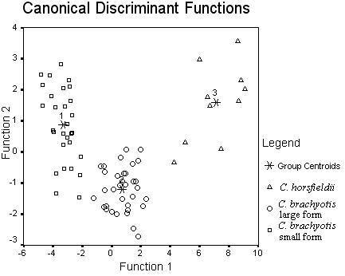

[Single spacing]
Figure 1: Number figure (Arabic) consecutively in accordance with their appearance in the text and to have a caption which should always be positioned under the figures.

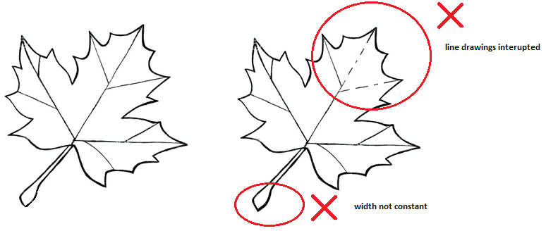
Figure 2: Guides for line drawing in figures.
[It is essential that all illustrations are clear and legible. Vector graphics should be used for diagrams and schemas whenever possible, line drawings are not interrupted and have a constant width. Grids and details within the figures must be clearly legible and may not be written one on top of the other. Line drawings are to have a resolution of at least 800 dpi (preferably 1200 dpi). The lettering in figures should not use font sizes smaller than 6 pt (~ 2 mm character height). Figures should be cross referred in the text. Caption should be justified, font Time New roman, size 12 point]
[Double spacing]

Formulas should be placed in a separate line and centred, spaced once, ended with a punctuation mark, tabbed three times and numbered. Expressions must be numbered consecutively and the numbers must be in bracket.

x + y = z (1)

Discussion must be a thorough analysis and interpretation of results in light of questions that prompted your study. Be sure to clarify whether results confirm or refute initial hypothesis. Discusses implications of work and its significance; suggests further research. Accounts for difficulties and challenges in the research, and problems in the research design. Note limitations of your approach. Clarifies how your work fits into the ongoing discussions of your field.
[Double spacing]
Subheading One
Use past tense for what was done in this study and what others found in their studies. Use present tense for universally accepted truths, findings believed to be repeatable and things really going on right now. Use future tense for what is planned for the next step, what impacts the results will have and how the results will be used.
[Double spacing]
Subheading Two
Further subheadings can be added to add sections to the discussion.
[Double spacing]

Conclusion

The conclusion connects the findings to a larger context, such as the wider conversation about an issue and the journal theme. It suggests the implications of your findings or the importance of the topic. Asking questions or suggesting ideas for further research and revisiting your main idea or research question with new insight.

[Double spacing]

References

JSSM articles follow APA style citations. Bibliography settings with assistant softwares eg. EndNote, Mendeley, BibTex etc should follow APA style.

For reference preparation, kindly refer: https://www.mendeley.com/guides/apa-citation-guide

Appendix

[Appendix if any should be placed after list of references. Appendix must be cited in the body text and number in Arabic; Double spacing]

